1. **Team members**:
   * Cameron L’Ecuyer – Class ID: 17 (Team Leader)
   * Sneha Mishra – Class ID: 21
   * Navya Pillala – Class ID: 26
   * Ruthvic Punyamurtula – Class ID: 30
   * <https://github.com/camlecuyer/CS5551_Team_11_Project>
2. **Project Goal**:

**Motivation**:

To develop an augmented reality application to assist users when shopping for clothing.

**Significance**:

Our application will be different from others in that in will an augmented reality mode to allow a person to "try on clothing" before buying.

**Objectives**:

* + - Develop an application that assists users who want to shop for clothing
    - Integrate social media to allow suggestions from the user’s friends
    - Integrate gamification features into the application to increase user involvement and retention
    - Integrate machine learning into the software for image recognition, speech recognition, and intelligent searching

**System Features**:

* + - Developed for the Android operating system
    - Clean and friendly UI
    - Integrated unobtrusive social media features
    - Integrated augmented reality features to give the user virtual access to clothing
      1. One feature may allow the user to change the color of clothing
      2. The user will also be able to specify their preferences
      3. The user will be shown results fitting to their body shape
    - Integrated searching of retail stores using available APIs
      1. Searching through retail stores will allow users to find similar objects to what they select.
      2. They will be able to find the location and price of the what they want to buy
    - Integrated image recognition will be used to determine the clothing parameters
    - Access to Speech-to-Text features for user’s who have trouble with a smart phone’s keyboard, poor eyesight, or who do not like typing
    - Gamification features to keep the user returning to the application
    - If time allows, integrated deals/coupons into the search mechanism to allow for better pricing options

**Related Work**:

* + - TheMine: Furniture placement app
    - IKEA place: Furniture placement app
    - Amazon Shopping: Furniture placement (iOS), product recognition using camera/barcode, and product search

**Bibliography**:

* + - TheMine app: https://itunes.apple.com/us/app/envisioned/id1293488677?ls=1&mt=8
    - IKEA place app: https://itunes.apple.com/us/app/ikea-place/id1279244498?mt=8
    - Amazon Shopping app: https://play.google.com/store/apps/details?id=com.amazon.mShop.android.shopping&hl=en
    - IBM Watson: https://www.ibm.com/watson/products-services/
    - Vuforia: https://library.vuforia.com/api
    - ARToolKit: https://www.artoolkit.org/documentation/
    - MaxST: https://developer.maxst.com/
    - Amazon API: https://docs.aws.amazon.com/AWSECommerceService/latest/DG/Welcome.html
    - Target API: https://developer.target.com/
    - Walmart API: https://developer.walmartlabs.com/
    - Google Speech-to-Text: <https://weston.ruter.net/2009/12/12/google-tts/>

1. **Project Plan:**

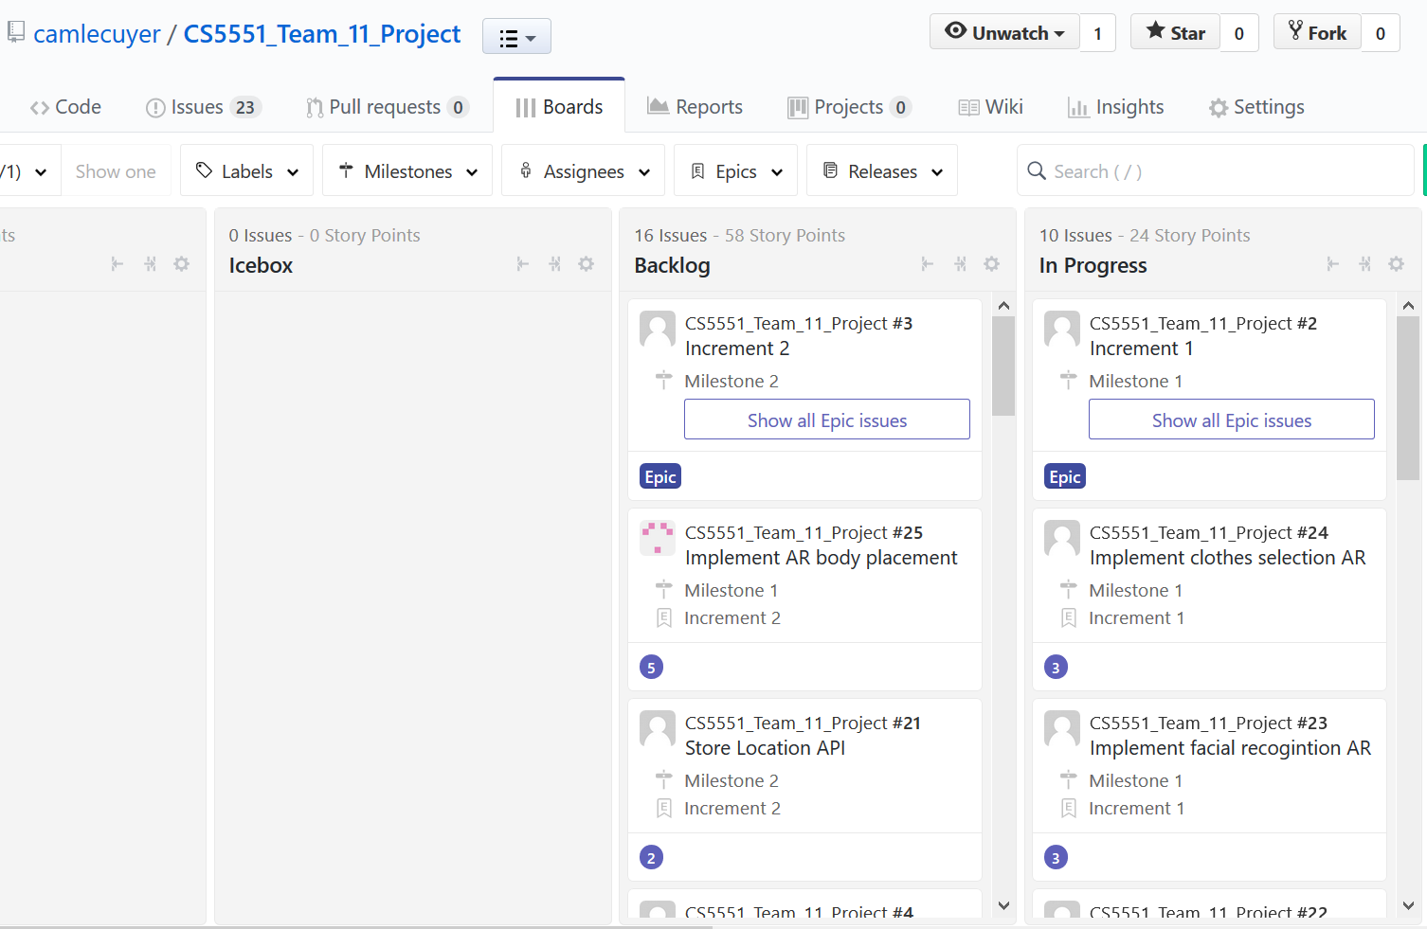

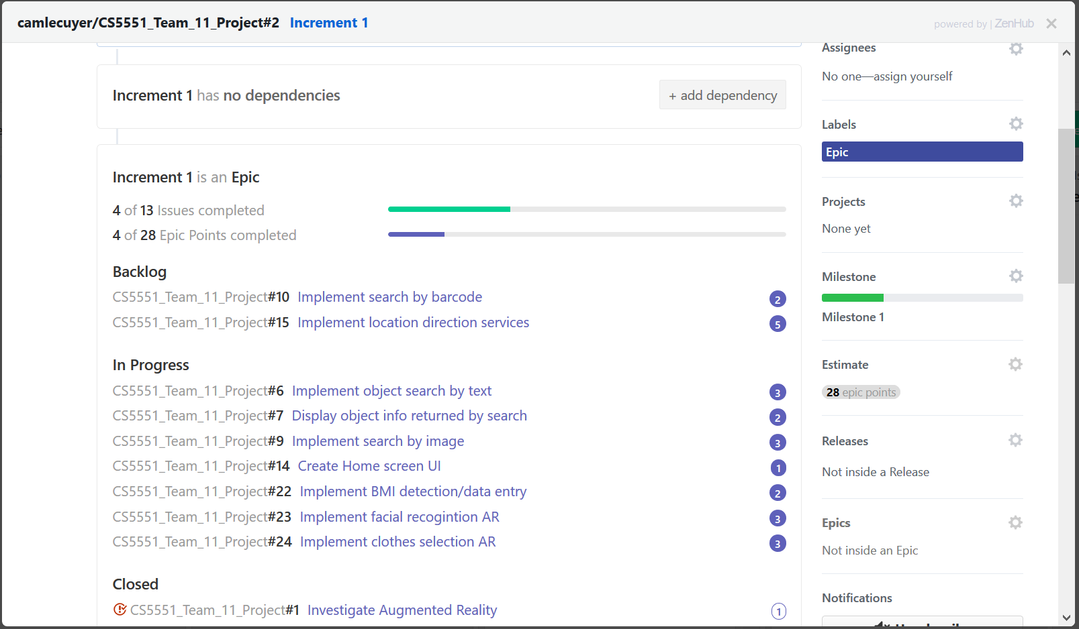

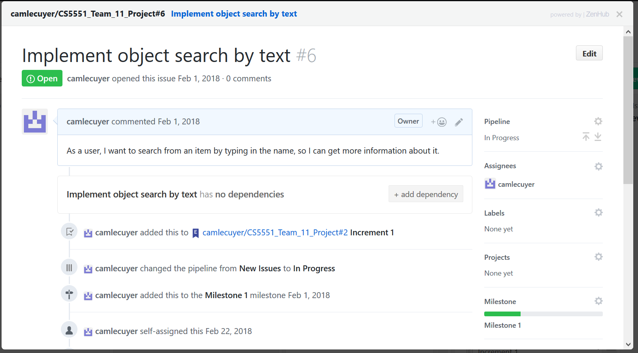

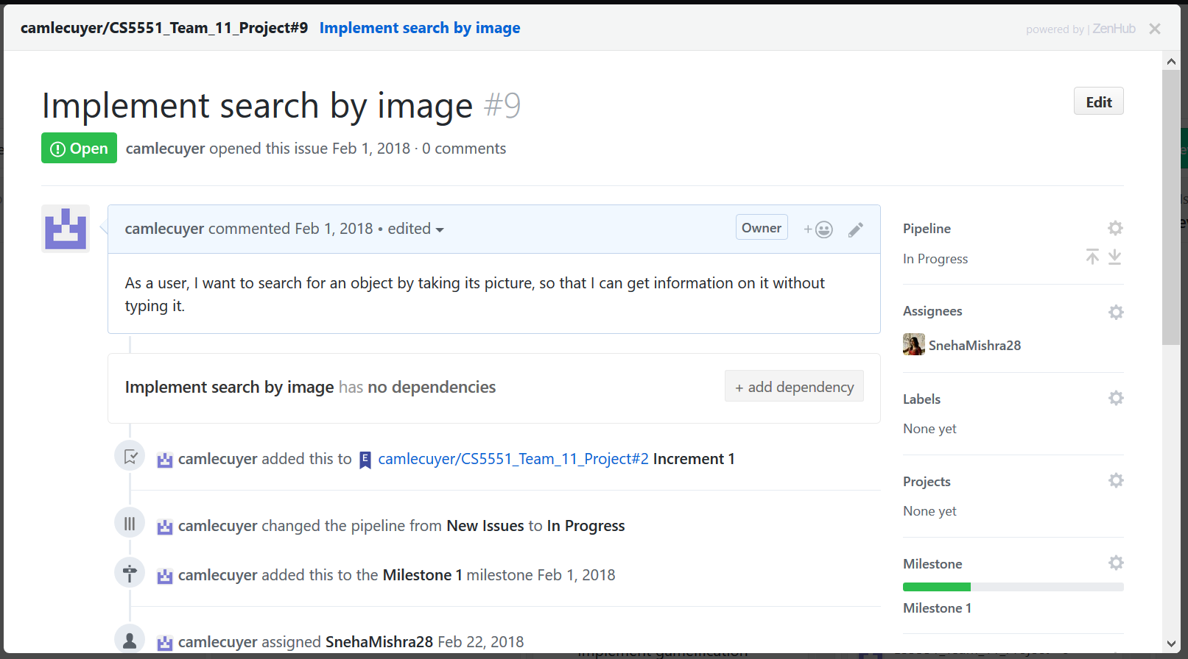

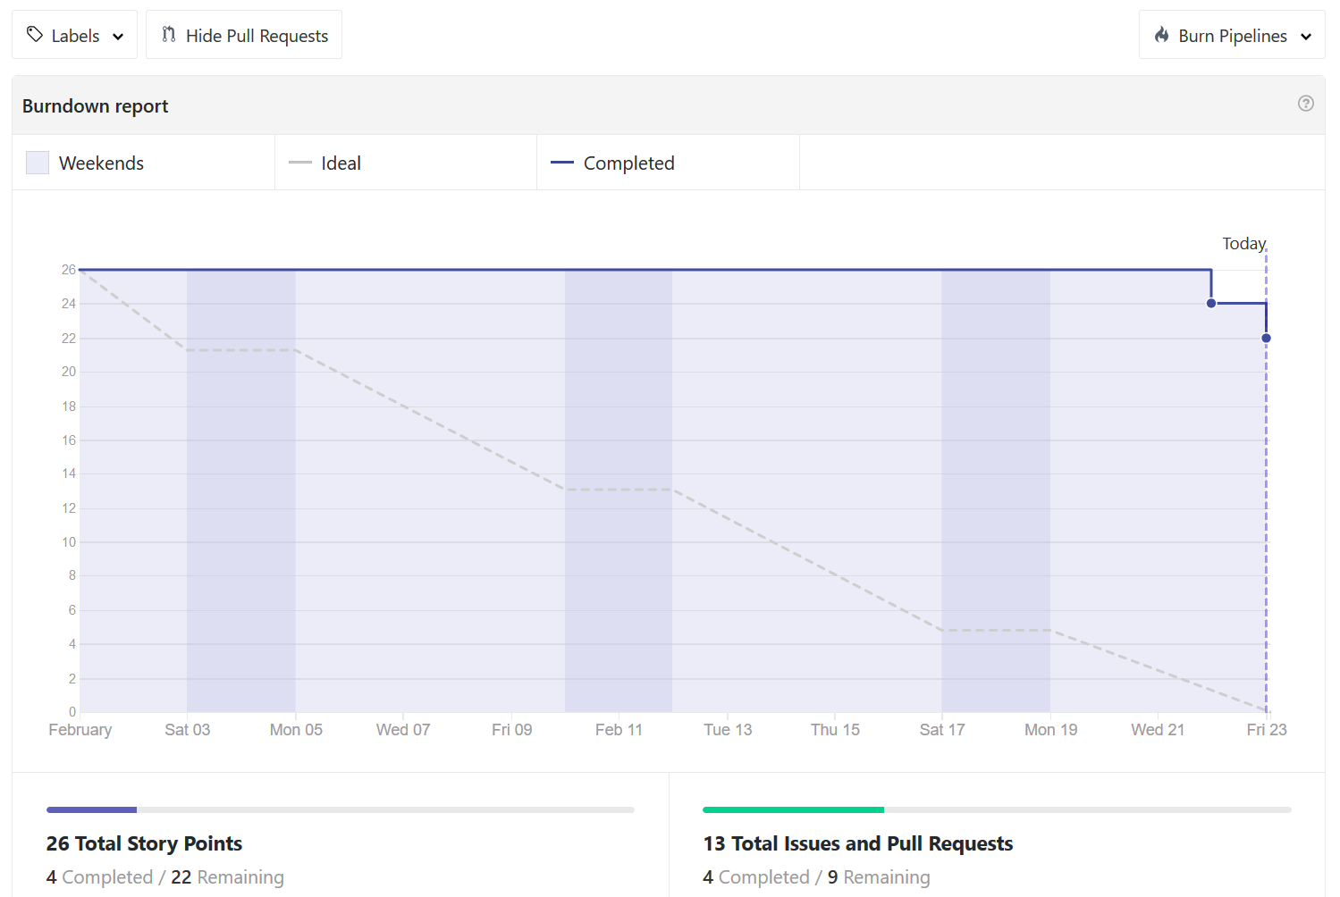

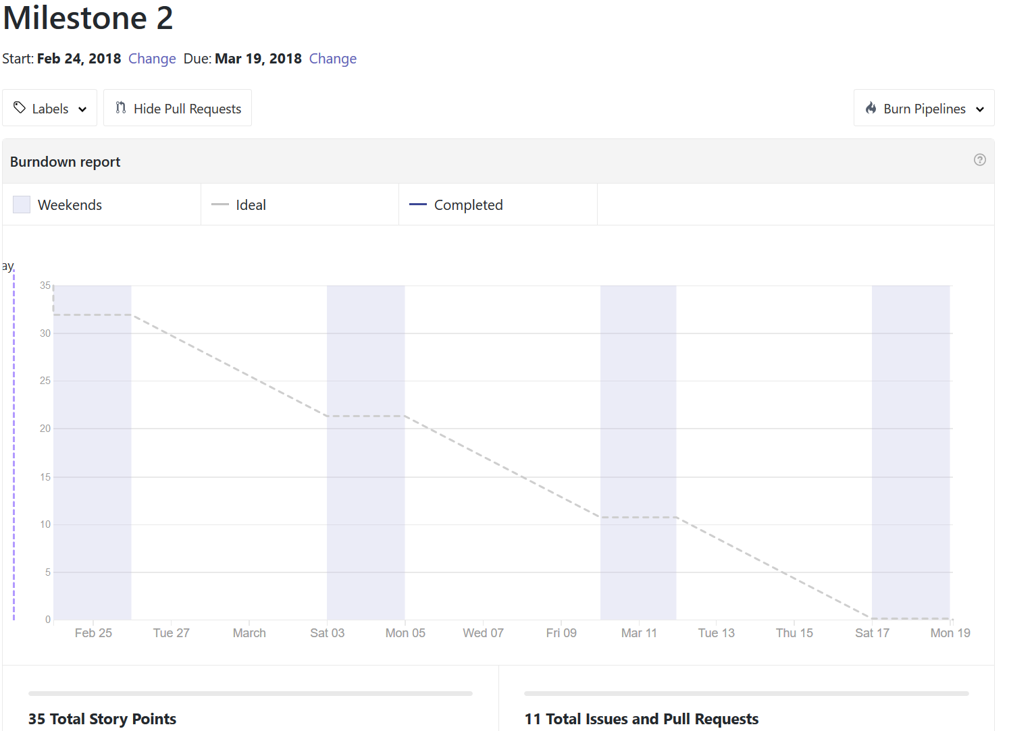

1. **First Increment Report**
   * Each team member submitted what they had completed and the APIs/services they used
   * Rothvic created the UML diagrams and Mock ups

* **Existing Services/REST API**
  + <https://www.faceplusplus.com/body-outlining/#demo>
  + <https://www.betafaceapi.com/wpa/>
  + <https://stackoverflow.com/questions/21698044/basic-bmi-calculator-html-javascript>
  + Google Reverse Image Search
  + Amazon Product Advertising API
  + Target API: https://developer.target.com/
  + Walmart API: <https://developer.walmartlabs.com/>
  + Macy’s API: <http://developer.macys.com/>
  + Google Network Framework - Volley for Android
* **Detail Design of Features:**

UI Mockups

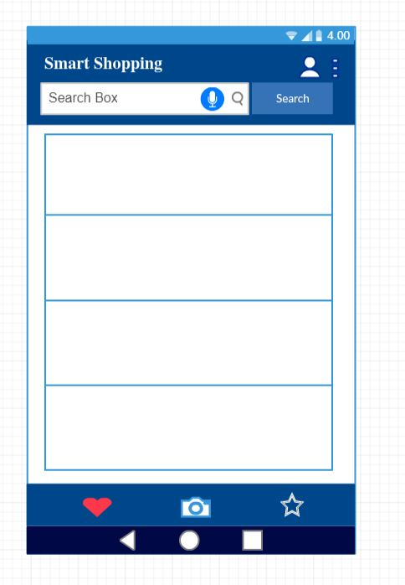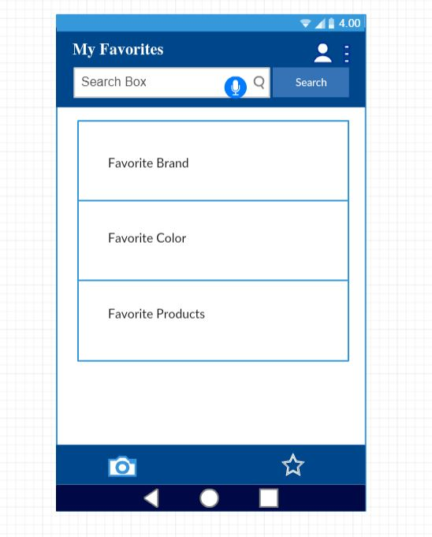

UML Diagrams

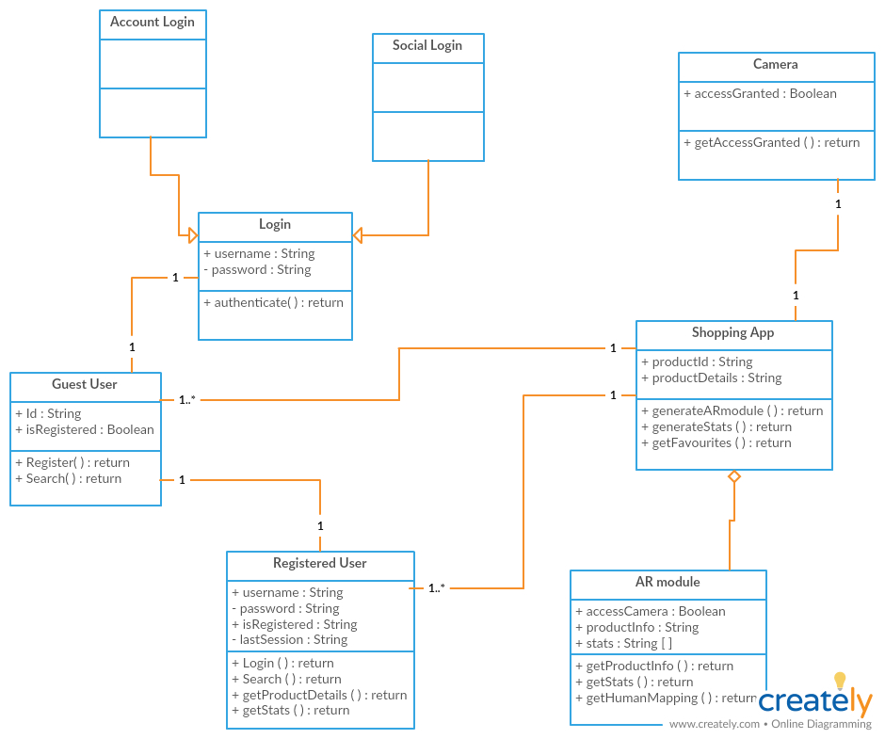

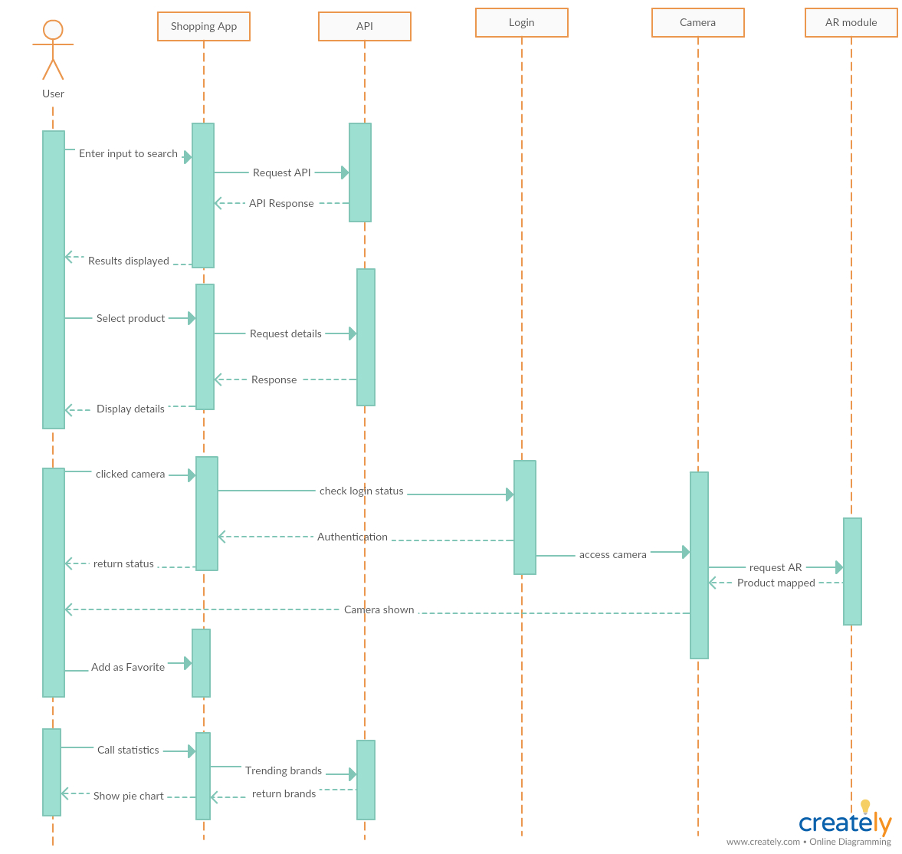

* **Testing**

|  |  |  |  |  |
| --- | --- | --- | --- | --- |
| **SNO** | **TEST CASE** | **DESCRIPTION** | **EXPECTED OUTCOME** | **RESULT** |
| **1** | To detect skin color | The API should detect skin color of given image | API must work |  |
| 2 | To define BMI of a person | BMI of a person should be calculated based on height and weight of a person | Exact BMI of a person is calculated | success |

* **Implementation**
  + Android Studio
  + Exploration of features done in HTML and JavaScript
* **Deployment**
  + Currently we only have the home page and the start of the page for the clothing search

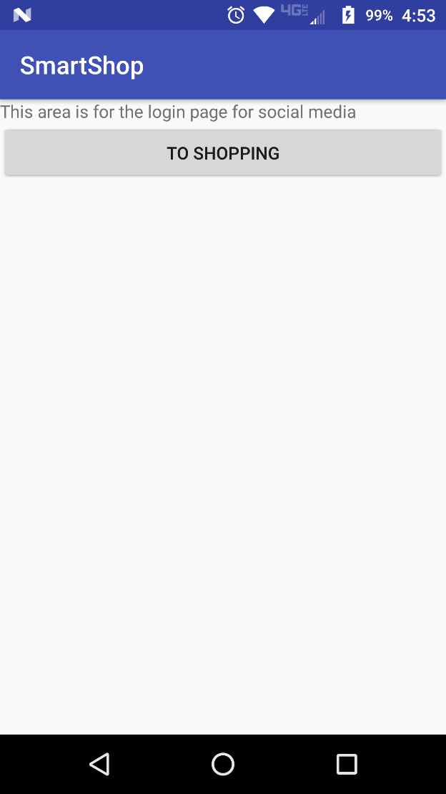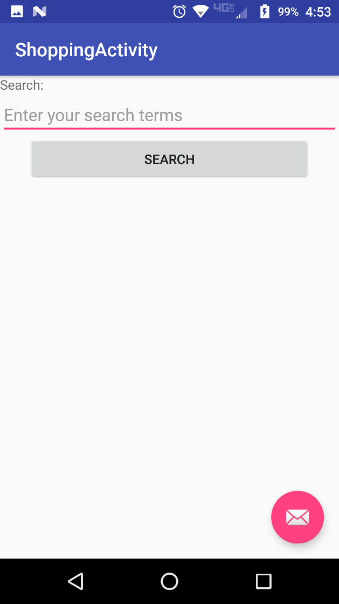

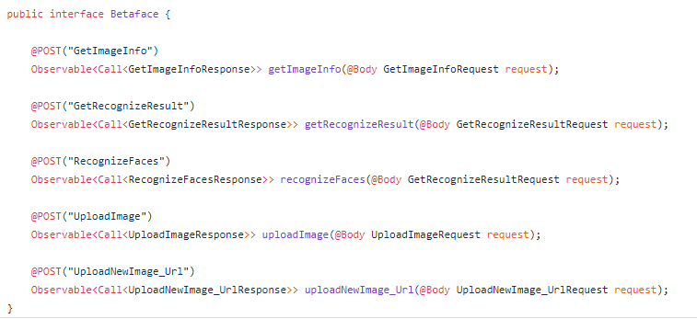Sample Code snippet of Betaface API

Sample code snippet of BMI**:**

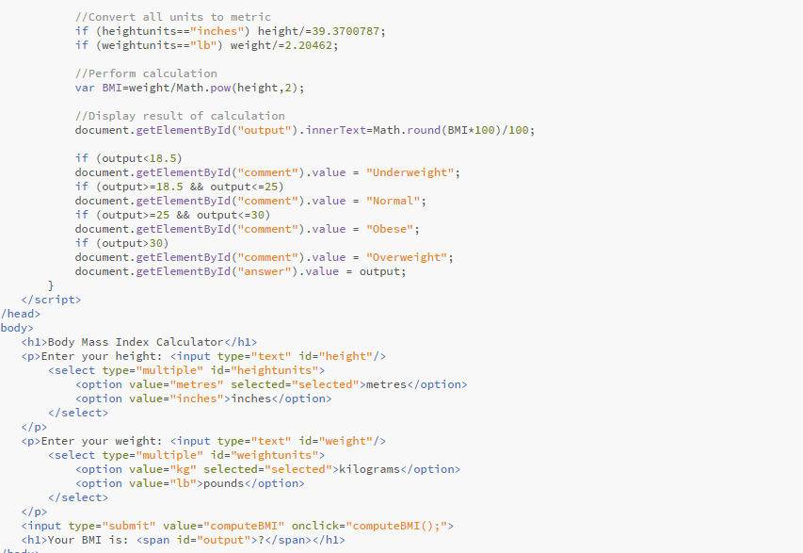

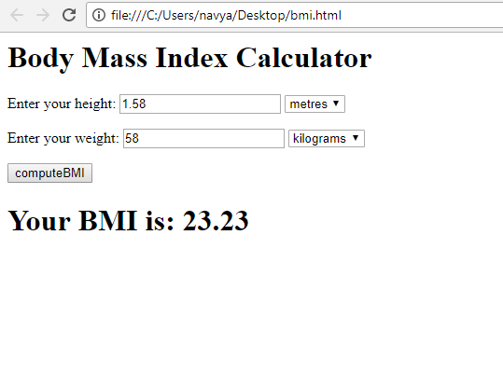Output of BMI code**:**

* **Project Management**
  + **Work Completed**
    - Rothvic
      * Created android UI mock up using wire frames for the respective pages which helps in building the app layout
      * Overall design of the application is represented using class diagram and sequence diagram
      * Researched on body detection API
      * I will be working on modelling the clothing product to the human in camera vision
    - Navya
      * Implemented BMI calculator
      * Implemented facial recognition
        + Betaface API is a face detection and face recognition web service. It can scan uploaded image files or image URLs, find faces, and analyze them. API also provides verification (faces comparison) and identification (faces search) services, as well able to maintain multiple user-defined recognition databases (namespaces).
        + This API helps us to estimate gender, age, ethnicity, emotion (smile/neutral), eyes, skin color, clothes and background colors etc.
    - Sneha
      * Worked on image search
      * Worked on Walmart API
    - Cameron
      * Worked on Walmart API
      * Worked on Amazon API
      * Worked on Target API
      * Worked on Macy’s API
      * Built UI for Android app
  + **Work to Be Completed**
    - Rothvic
      * Finish implementing Body AR
    - Sneha
      * Image recognition
    - Cameron
      * Due to problems getting a product API, I may have to implement a static database for product items before the searching will work
      * Search for objects using text
      * Display search results
* **Issue**
  + Will we be able to map the product on the image?
  + Google Reverse Image Search APIs are deprecated
  + The retail APIs are causing problems:
    - Target API is only available to Target affiliates
    - Walmart API will not send confirmation email to access site
    - Macy’s API gave a key, but will not activate it
    - Amazon API requires Amazon’s Associates Program, which requires a fully developed and deployed website/app for them to review before you are approved